MATHEMATICS
FOR
IIT-JEE(MAINS & ADVANCED)
BY MANISH KALIA
(B.TECH DELHI COLLEGE OF ENGINEERING)

TARGET –CBSE
FOR CBSE EXAM –XI

9464551253,9878146388
www.alphaclasses.com
www.iitmathematics.com

TARGET –CBSE
FOR CBSE EXAM –XI

CHAPTER 1(SETS)
Objective
Q1 Write the set A = {1, 4, 9, 16, 25, . . . }in set-builder form.
Q2 Write the set,in the set builder form
Q3 If universal set S={0,1,2,3,4,5,6,7,8,9} and A={1,2,3,4},B={2,3,5,6} and C={2,3,7},then find
- A’ b) (A-B)’ c) B’-A’ d) A’∩B e) AUB’ f) (A∩C)’
Q4 In a survey of 400 students in a school, 100 were listed as taking apple juice, 150 as taking orange juice and 75 were listed as taking both apple as well as orange juice. Find how many students were taking neither apple juice nor orange juice.
Q5 List all the subsets and the proper subsets of the set {-1,0,1}
Q6 In a certain city,only two newspapers A and B are published .It is known that 25% of the city population reads A and 20% reads B ,while 8% reads both A and B .It is also known that 30% of those who read A but not B,look into advertisements and 40% of those who read B but not A ,looks into advertisements while 50% of thise who read both A and B,look into advertisements.What % of population read an advertisement.
Q7 From 50 students taking examinations in Mathematics, Physics and Chemistry, each of the student has passed in at least one of the subject, 37 passed Mathematics, 24 Physics and 43 Chemistry. At most 19 passed Mathematics and Physics, at most 29 Mathematics and Chemistry and at most 20 Physics and Chemistry. What is the largest possible number that could have passed all three examination?
Q8 A college awarded 38 medals in football, 15 in basketball and 20 in cricket. If these medals went to a total of 58 men and only three men got medals in all the three sports, how many received medals in exactly two of the three sports ?
Q9 Let A and B be sets. If A ∩ X = B ∩ X = φ and A ∪ X = B ∪ X for some set X, show that A = B.
Q10 In a survey of 60 people, it was found that 25 people read newspaper H, 26 read newspaper T, 26 read newspaper I, 9 read both H and I, 11 read both H and T, 8 read both T and I, 3 read all three newspapers. Find:
(i) the number of people who read at least one of the newspapers.
(ii) the number of people who read exactly one newspaper.
Q11 If A={a,b,c},then what is the number of proper subsets of A
Q12 If A ={1,2,3} and B={2,4,5} find A Δ B
Q13 Draw the Venn diagrams to illustrate the following relationship among sets E, M and U, where E is the set of students studying English in a school, M is the set of students studying Mathematics in the same school, U is the set of all students in that school.
(i) All the students who study Mathematics study English, but some students who study English do not study Mathematics.
(ii) There is no student who studies both Mathematics and English.
(iii) Some of the students study Mathematics but do not study English, some study English but do not study Mathematics, and some study both.
(iv) Not all students study Mathematics, but every students studying English studies Mathematics.
Q14 Two finite sets have m and n elements respectively. The total number of subsets of first set is 56 more than the total number of subsets of the second set. The values of m and n respectively are.
Case Study Based Questions
Q15 In a school, during the new academic session 2024-2025, in all sections of class XI, out of 200 students, 30 students offered English only, 24 students offered Sanskrit only, 16 students offered only Hindi, 80 students offered Hindi and English, 40 students offered Hindi and Sanskrit, 20 students offered English and Sanskrit, 130 students offered Hindi.
Based on the above information answer the following questions:
(a) Find the number of students who offered all the three subjects.
(b) Find the number of students who offered English.
(c) Find the number of students who offered Sanskrit
(d) Find the number of students who offered English and Sanskrit but not Hindi
Q16 In a library, 25 students are reading books on physics, chemistry, and mathematics. It was found that 15 students were reading mathematics, 12 reading physics and 11 reading chemistry, 5 students reading both mathematics and chemistry, 9 students reading both physics and mathematics, 4 students reading both physics and chemistry, and 3 students reading all three subjects.
(a) Find the number of students reading only Chemistry.
(b) Find the number of students reading only Mathematics.
(c) Find the number of students reading at least one of the subject and also find the number of
students reading none of the subjects.

Chapter 2(RELATIONS AND FUNCTIONS)
Q1 If find the values of x and y.
Q2 Let A = {1,2,3}, B = {3,4} and C = {4,5,6}. Find
- A × (B ∩ C) (ii) (A × B) ∩ (A × C) (iii) A × (B ∪ C) (iv) (A × B) ∪ (A × C)
Q3 Let A = {1, 2, 3, 4, 6}. Let R be the
relation on A defined by
{(a, b): a , b ∈A, b is exactly divisible by a}.
(i) Write R in roster form
(ii) Find the domain of R
(iii) Find the range of R.
Q4 Which of the following relations are functions? Give reasons. If it is a function,
determine its domain and range.
(i) {(2,1), (5,1), (8,1), (11,1), (14,1), (17,1)}
(ii) {(2,1), (4,2), (6,3), (8,4), (10,5), (12,6), (14,7)}
(iii) {(1,3), (1,5), (2,5)}.
Q5 Draw the graph of the function
Q6 Find the domain and range of the following real functions:
(i) f(x) = – (ii) f(x) =
Q7 Let f = {(1,1), (2,3), (0, –1), (–1, –3)} be a linear function from Z into Z. Find f(x).
Q8 Draw the graph of the function
Q9 Find the domain of the function f (x)=
Q10 Let be a function from R into R. Determine the range of f.
Q11 Let f be the subset of Z × Z defined by f = {(ab, a + b) : a, b ∈ Z}. Is f a function from Z to Z? Justify your answer.
Q12 Let A = {9,10,11,12,13} and let f : A→N be defined by f (n) = the highest prime factor of n. Find the range of f.
Q13 Redefine the function which is given by f (x) = , – 2 ≤ x ≤ 2
Q14 Let 'R' be the relation in the set A = { 2 , 3, 8 , 5, 6,} to A, defined by R = { (x, y) : x - y is divisible by 3}.Write 'R' in Roster form and hence find its domain, range and co- domain.Also find R⁻¹
Q15 Find domain and range of f (x) = ; where f (x) is a real valued function. [CBSE-2014]

Q16 Find the domain and range of the relation R given by
Q17 Draw the graph of greatest integer function .
Q18 Find the domain of
Q19 Let n (A) = m, and n (B) = n. Then the total number of non-empty relations that can be defined from A to B is
Q20 Find the domain and range of
Q21 Let A = {–2, –1, 0, 1, 2} and f : A → Z be given by f (x) = x² – 2 x – 3. Find:
(a) the range of f
(b) pre-images of 6, – 3 and 5.
Case Study Based Questions
Q22 A teacher asked randomly his two students to draw graph (figure) on the black board. Two students Raman and Prashant draw figure (graphs) (a) and (b) one by one on the board as shown below:
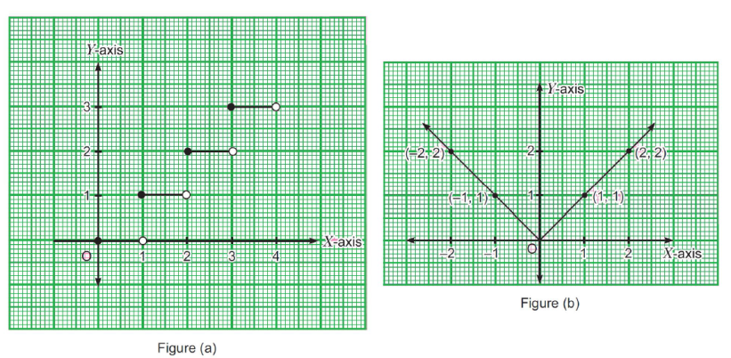
(i) For the figure (a), write the function in terms of x.
(ii) (a) For the figure (b), write the function in terms of x.
OR
(ii) (b) Write the range of the function f(x) of the figure (a).
(iii) The function f : R → R defined by f(x) = |x| then write the value of f(– 3).
Chapter 3(TRIGONOMETRIC FUNCTIONS)

Q1 Convert 40° 20′ into radian measure.
Q2 The minute hand of a watch is 1.5 cm long. How far does its tip move in 40 minutes? (Use π = 3.14).
Q3 Find the value of cos (–1710°) and sin(-11π/3)
Q4 Show that tan 3 x tan 2 x tan x = tan 3x – tan 2 x – tan x
Q5 Prove that
Q6 Prove that
- sin² 6x – sin² 4x = sin 2x sin 10x
Q7 Prove that
Q8 If a cos θ + b sin θ = m and a sin θ – b cos θ = n, then show that a² + b² = m² + n²
Q9 Find the value of tanπ/8
Q10 Find Sin , cos & tan if tan x = , where x lies in the 3rd quadrant. [CBSE-2014]
Q11 Show that 2 sin² β + 4 cos (α + β) sin α sin β + cos 2 (α + β) = cos 2α
Q12 Prove that
Q13 If tan x = and tan y = ; then what is the value of ( x + y ) [CBSE-2014]
Q14 If A+B=45º , then show that

Q15 Find the value of cosec 20° – sec 20°
Q16 What is the value of cot (870º)?
Q17 Find the maximum value of √3 sin θ – cos θ+7
Q18 What is the value of
Q19
Q20 Consider the following statements :
1. The value of cos 46° – sin 46° is positive.
2. The value of cos 44° – sin 44° is negative.
Which of the above statement is/are correct ?
(a) 1 only (b) 2 only (c) Both 1 and 2 (d) Neither 1 nor 2
MCQ
Case Study Based Questions
Q21
A railway train is travelling on a circular curve of 1500 metres radius at the rate of 66 km/h.
Now, answer the following:
(i) Find the angle in radians by which it turned in 10 seconds.
(ii) Find the degree measure of the angle turned by railway train in 10 seconds.
(iii) How much degree will train turn in 20 seconds?
OR
- If train changes its speed to 60 km/h then what angle will train turn in 10 seconds.
Q22 Observe the below graph carefully answer the following
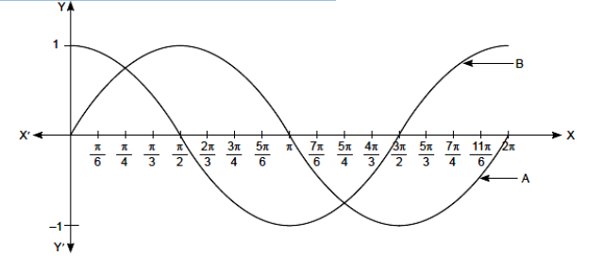
(i) Graph A represent the graph of which trigonometric function.
(ii) Graph B represent the graph of which trigonometric function.
(iii) From the above graph write the principal value of x if sin x = 1
(iv) From the graph find the angle for which the value of sin x and cos x is same.

Chapter 4(COMPLEX NUMBERS AND QUADRATIC EQUATIONS)

Q1 Find the multiplicative inverse of 4 – 3i.
Q2 Find the number of non-zero integral solutions of the equation
Q3 Express the following expression in the form of a + ib
Q4 Convert the complex number in the polar form
Q5 Find real values of x and y for which the complex numbers (- 3 + ix²y) and( x² + y +4i) are complex conjugate of each other.
Q6 Find the square root of 7 – 24i.
Q7 Find the value of 2x⁴ + 5x³ + 7x² – x + 41, when x = – 2 – 3 i
Q8 If a and b are different complex numbers with ,then find the value of [CBSE-2014]
Q9 If (x + iy)³ = u + iv, then show that [CBSE-2014]
Q10 For any positive integer n,prove that
Q11 Find the multiplicative inverse of
Q12 If ,where ‘c’ is real, prove that and
Q13 If where x,y,a,b∈R,show that
Q13 If ,where Z is a complex number,show that
Q14 If where z=x+iy is a complex number ,then show that |z|=1

Chapter 5(LINEAR INEQUALITIES)

Q1 Solve the inequalities
- 2 (2x + 3) – 10 < 6 (x – 2)
- 5x – 3 > 3x – 5

Q2 The longest side of a triangle is 3 times the shortest side and the third side is 2 cm shorter than the longest side. If the perimeter of the triangle is at least 61 cm, find the minimum length of the shortest side.

Q3 Solve the following system of inequalities graphically:
- x + y ≤ 9, y > x, x ≥ 0
- 4x + 3y ≤ 60, y ≥ 2x, x ≥ 3, x, y ≥ 0
Q4 A solution of 8% boric acid is to be diluted by adding a 2% boric acid solution to it. The resulting mixture is to be more than 4% but less than 6% boric acid. If we have 640 litres of the 8% solution, how many litres of the 2% solution will have to be added?
Q5 How many litres of water will have to be added to 1125 litres of the 45% solution of acid so that the resulting mixture will contain more than 25% but less than 30% acid content?
Q6 Solve 1 ≤ |x –2 | ≤ 3.
Q7 Solve for x, |x +1| + |x| > 3
Q8 Solve for x
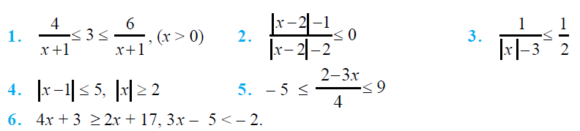
Q9 The water acidity in a pool is considerd normal when the average pH reading of three daily measurements is between 8.2 and 8.5. If the first two pH readings are 8.48 and 8.35, find the range of pH value for the third reading that will result in the acidity level being normal.
Q10 In drilling world’s deepest hole it was found that the temperature T in degree celcius, x km below the earth’s surface was given by T = 30 + 25 (x – 3),3 ≤ x ≤ 15. At what depth will the temperature be between 155°C and 205°C?
Case Study Based Questions
Q11 Aditya’s mother gave him Rs. 200 to buy some packets of rice and maggie from the market. The cost of one packet of rice is Rs. 30 and that of one packet of maggie is Rs. 20. Let x denotes the number of packet of rice and y denotes the number of packets of maggie.
(a) Find the inequality that represents the given situation. (1)
(b) If he buys 4 packets of rice and spends entire amount of Rs. 200, then find the maximum number
of packets of maggie that he can buy. (1)
(c) Solve the following inequality for real x: 4x + 3 < 5x + 7 (2)
Q12 An intelligence quotient (IQ) is a total score derived from a set of standardised tests or subtests designed to assess human intelligence. The abbreviation "IQ" was coined by the psychologist William Stern for the German term Intelligence quotient, his term for a scoring method for intelligence tests at University of Breslau he advocated in a 1912 book.
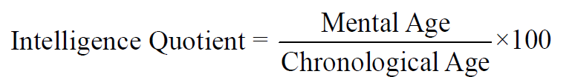
(a) What could be the range if mental age if a group of children with chronological age of 15 years have the IQ range as 90 ≤ IQ ≤ 150?
(b) What could be the range of IQ if a group of children with age of 12 years have the mental age
range as 9 ≤ MA ≤ 15?
OR
(b) What could be the range of IQ if a group of children with mental age of 18 years have the mental age range as 12 ≤ CA ≤ 15?

Chapter 6(PERMUTATIONS AND COMBINATIONS)
Q1 Find the number of different signals that can be generated by arranging at least 2 flags in order (one below the other) on a vertical staff, if five different flags are available.
Q2 Find the number of different 8-letter arrangements that can be made from the letters of the word DAUGHTER so that
- all vowels occur together (ii) all vowels do not occur together
Q3 Find the number of arrangements of the letters of the word INDEPENDENCE. In how many of these arrangements,
- do the words start with P
- do all the vowels always occur together
- do the vowels never occur together
- do the words begin with I and end in P?
Q4 In how many ways can the letters of the word PERMUTATIONS be arranged if the
i)words start with P and end with S, (ii) vowels are all together, (iii) there are always 4 letters between P and S? [CBSE-2014]
Q5 What is the number of ways of choosing 4 cards from a pack of 52
playing cards? In how many of these
(i) four cards are of the same suit,
(ii) four cards belong to four different suits,
(iii) are face cards,
(iv) two are red cards and two are black cards,
v) cards are of the same colour?
Q6 In how many ways can a student choose a programme of 5 courses if 9 courses are available and 2 specific courses are compulsory for every student?
Q7 group consists of 4 girls and 7 boys. In how many ways can a team of 5 members be selected if the team has (i) no girl ? (ii) at least one boy and one girl ?(iii) at least 3 girls ?
Q8 Find the number of words with or without meaning which can be made using all the letters of the word AGAIN. If these words are written as in a dictionary, what will be the 50th word?
Q9 How many numbers greater than 1000000 can be formed by using the digits 1, 2, 0, 2, 4, 2, 4?
Q10 In how many ways can the letters of the word ASSASSINATION be arranged so that all the S’s are together ?
Q11 It is required to seat 5 men and 4 women in a row so that the women occupy the even places. How many such arrangements are possible ?
Q12 A student has 3 library tickets and 8 books of his interest in the library. Of these 8 books; he does not want to borrow Mathematics Part II , unless Mathematics Part I is also borrowed. In how many ways can he choose the three books to be borrowed. (If one book is issued for one ticket), What role library can play in students' life? [CBSE-2014]
Q13 In how many ways can 5 children be arranged in a line such that (i) two particular children of them are always together (ii) two particular children of them are never together.
Q14 In a small village, there are 87 families, of which 52 families have atmost 2 children. In a rural development programme 20 families are to be chosen for assistance, of which atleast 18 families must have at most 2 children. In how many ways can the choice be made?
Q15 If the letters of the word RACHIT are arranged in all possible ways as listed in dictionary. Then what is the rank of the word RACHIT ?
Case Study Based Questions
Q16 Raj works at a book store. While arranging some books on the book shelf, he observed that there are 5 History books, 3 Mathematics books and 4 Science books which are to be arranged on the shelf.
(i) In how many ways can he select either a History book or a Maths book? (1)
(ii) If he selects 2 History books, 1 Maths book and 1 Science book to arrange them, then find the number of ways in which selection can be made. (1)
(iii) Find the number of ways, if the books of same subject are put together. (1)
(iv) Find the number of arrangements, if he selects 3 History books, 2 Maths Books, 2 Science books. (1)

Q17 Seema wants a mobile number having 10 digits. It is not just a group of numbers strung out at random. All mobile numbers have 3 things in common. a 2-digit Access code (AC), a 3-digit provider code (PC), and a 5 digit subscriber code (SC). AC code and PC code are fixed, then
(i) How many mobile numbers are possible if no start with 98073 and no other digit can repeat? (1)
(ii) How many AC code are possible if both digit in AC code are different and must be greater than 6? (1)
(iii)How many mobile numbers are possible if AC and PC code are fixed and digits can repeat? (1)
(iv) How many mobile numbers are possible with AC code 98 and PC code 123 and digit used in AC and PC code will not be used in SC code? (1)
Chapter 7(Binomial theorem)

Q1 Evaluate
Q2 Find (a + b)⁴ – (a – b)⁴. Hence, evaluate
Q3 Find the 7th term in the expansion of
Q4 Show that the middle term in the expansion of is ,where n is a positive integer.
Q5 if three successive coefficients in the expansion of (1+x)^{n} are 220,495 and 792,then find n.
Q6 if the 3rd,4th and 5th terms in the expansion of (x+a)^{n} are 84,280 and 560 respectively,then find the values of a,x and n.
Q7 In the expansion of ,the ratio of the 7th term from the beginning to the 7th term from the end is 1:6,find n
Q8 The coefficients of the (r – 1)^{th}, r^{th} and (r + 1)^{th} terms in the expansion of (x + 1)^{n} are in the ratio 1 : 3 : 5. Find n and r.
Q9 Using binomial theorem, prove that 6^{n}–5n always leaves remainder 1 when divided by 25.
Q10 Which is larger (1.01)¹⁰⁰⁰⁰⁰⁰ or 10,000?
Q11 The total number of terms in the expansion of (x + a)⁵¹ – (x – a)⁵¹ after simplification is
Q12 The ratio of the coefficient of x¹⁵ to the term independent of x in is
Q13 The middle terms in the expansion of
Q11 In the expansion of if the sum of odd terms is P and sum of even terms is Q.Prove that
- ii)

Chapter 8(SEQUENCES AND SERIES)
Q1 The ratio of the sums of m and n terms of an A.P. is m² : n². Show that the ratio of m^{th} and n^{th} term is (2m – 1) : (2n – 1).
Q2 If is the A.M. between a and b, then find the value of n.
Q3 The sum of first p,q,r terms of an AP are a,b,c respectively .Show that
Q4 Between 1 and 31, m numbers have been inserted in such a way that the resulting sequence is an A. P. and the ratio of 7th and (m – 1)^{th} numbers is 5 : 9. Find the value of m.
Q5 150 workers were engaged to finish a piece of work in a certain number of days.Four workers dropped the second day,four more workers dropped the third day and so on.It takes 8 more days to finish the work now.Find the number of days in which the work was completed.
Q7 If the first and the nth terms of a G.P are a & b respectively and if p is the product of the first n terms ,then prove that
Q8 Find the sum of n terms of the series 8+8+888+………+ nterms
Q9 Find the value of n such that is the geometric mean between a & b.
Q10 If is a function satisfying for all x,y ∈N such that and .Find the value of n.
Q11 If A be the A.M. and G be the G.M. between the two numbers ,show that two numbers are
Q12 If a,b,c,d and p are different real numbers such that ,then show that a,b,c,d are in G.P.
Q13 If p,q,r are in G.P. and the equations, px² + 2qx + r = 0 and dx² + 2ex + f = 0 have a common root, then show that are in A.P.
Q14 Let S be the sum .P the product and R the sum of reciprocals of n terms in a G.P. Prove that
Case Study Based Questions
Q15A sequence of non-zero numbers is said to be a geometric progression, if the ratio of each term,
except the first one, by its preceding term is always constant. Rahul, being a plant lover, decides to open a nursery and he bought few plants and pots. He wants to place pots in such a way that the number of pots in the first row is 2, in second row is 4 and in the third row is 8 and so on…..
(a) Find the constant multiple by which the number of pots is increasing in every row (1)
(b) Find the number of pots in 8th row. (1)
(c) Find the difference in number of pots placed in 7th row and 5th row (2)
OR
(c) If Rahul wants to place 510 pots in total , then find the total number of rows formed in this
arrangement (2)
Q16 In Rangoli competition in school, Preeti made Rangoli in the equilateral shape. Each side of an equilateral triangle is 24 cm. The mid-point of its sides are joined to form another triangle. This process is going continuously infinite.
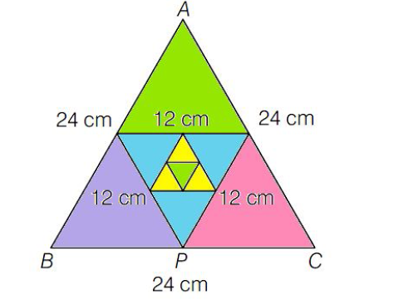
Based on above information, answer the following questions.
(a) Find the side of the 5th triangle is (in cm) (1)
(b) Find the sum of perimeter of first 6 triangle is (in cm) (2)
OR
(b) Find the area of all the triangle is (in sq cm). (2)
(c) Find the sum of perimeter of all triangle is (in cm). (1)

